Activity log:

GDC template

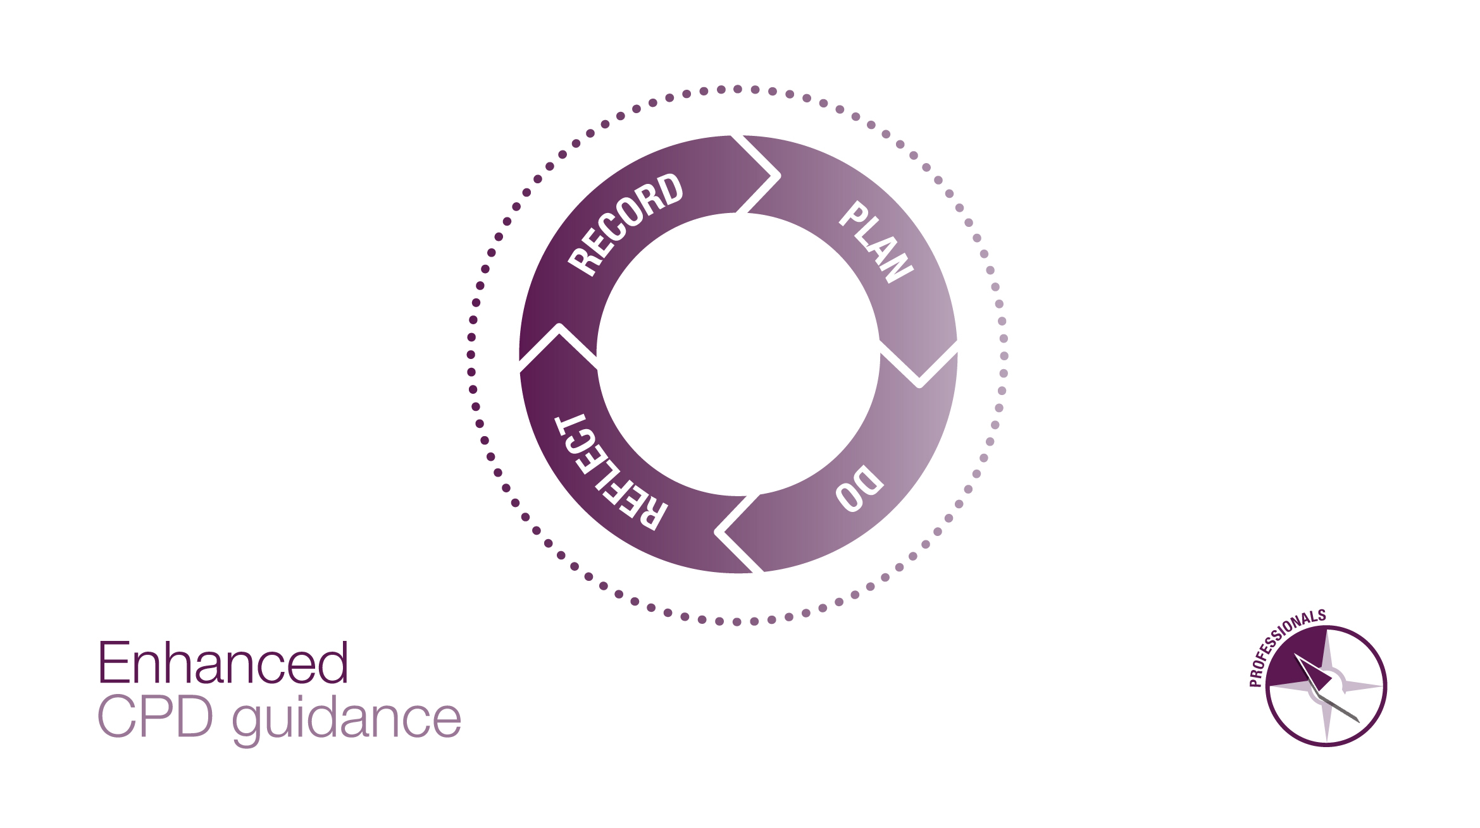

CPD activity log
As part of your CPD record for the GDC, you need to keep a log of all activity you have undertaken, which must include the following details:
- The title and description of the CPD activity you completed;
- The date it was undertaken;
- The number of hours, as shown on the evidence of completion (e.g. certificate) provided by the course provider. (Breaks and travel time do not count towards the number of hours of CPD);
- The GDC’s development outcome(s) achieved from each CPD activity.
It should also include a reflective element, or an indication that reflection has taken place.
For any CPD to be considered verifiable, the activity must be recorded on your activity log, and you must have collected corresponding evidence (e.g. certificates). If the GDC requests to see your CPD record, please do not include any information about any non-verifiable CPD you have completed in your cycle.

The development outcomes:
Below are the development outcomes and examples of what kinds of CPD might be linked to each. It is possible for some CPD activities to link to multiple outcomes. The GDC encourages you to choose CPD to cover all four development outcomes in your cycle, however this is not a compulsory requirement. You must make sure each planned and completed activity has at least one outcome (A, B, C, D) linked.

Development Outcome | Example of CPD content
- Effective communication with patients, the dental team and others across dentistry, including when obtaining consent, dealing with complaints, and raising concerns when patients are at risk; | - Communication skills  - Consent  - Complaints handling  - Raising concerns  - Safeguarding
- Effective management of self and effective management of others or effective work with others in the dental team, in the interests of patients at all times; providing constructive leadership where appropriate; | - Effective practice management  - Business management  - Team working
- Maintenance and development of knowledge and skill within your field of practice; | - Clinical and technical areas of study  - Radiography  - Cross infection control  - Medical emergencies and CPR  - CPD on quality assurance for MHRA  - CPD specific for your daily role(s)  - Upskilling opportunities
- Maintenance of skills, behaviours and attitudes which maintain patient confidence in you and the dental profession and put patients’ interests first. | - Ethical and legal issues and developments  - Professional behaviours  - Equality and diversity training

The GDC’s activity log template
The GDC has provided an activity log template which we think helps professionals clearly account for all activity completed, and includes a reflective element. However, you are free to choose any other tools or templates instead, to help you get the most out of your CPD. You may create your own, or use one created by your employer, colleagues, associations, professional bodies etc., as long as the GDC’s requirements are met.

Activity log
Name: Registration number: Cycle period:
Date | Hours  completed | Evidence of verifiable CPD?  (e.g. certificate) | Title, provider and content of CPD activity | Development  outcome(s) | How did this activity benefit my daily work?
The date(s) which you undertook the CPD activity. | CPD hours as confirmed by the relevant certificate. | Please ensure you gain evidence for all verifiable activity that you are counting for your CPD record. | Title that the provider uses, name of provider, and what was covered in activity. | A, B, C, D | In reflecting on your CPD activity, you might like to think about the following:  - What did you learn (or confirm) from the activity that was helpful or relevant to your daily work and patients?  - Did you identify any changes/updates needed in your daily work, and if so, what? How did you make these changes?  - If you didn’t identify changes needed, what did the activity confirm for you, that you may already know or be doing?  - What was the benefit to your work and/or your patients in carrying out this activity?
Insert more rows by right clicking in a row, click “insert” and “insert rows below”

