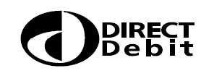
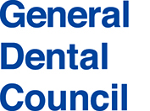

Please complete this form in pen
in BLOCK CAPITALS and return to:

Renewal Team

General Dental Council
1 Colmore Square
Birmingham B4 6AJ
Instruction to your Bank or Building Society to pay by Direct Debit
Service User Number: 758578

REGISTRANT’S FULL NAME: GDC REGISTRATION NUMBER:

Account Holder Name

Bank or Building Societies Account Number

Bank or Building Society Sort Code

Banks and Buildings Societies may not accept Direct Debit Instructions for some types of accounts.
Name and Address of your UK Bank or Building Society

Name and Address of Account Holder
Instruction to your Bank or Building Society: Please pay the General Dental Council Direct Debits from the account detailed in this Instruction subject to the safeguards assured by the Direct Debit Guarantee. I understand that this Instruction may remain with the General Dental Council and if so, details will be passed electronically to my Bank/Building Society.

Signature(s) of Account Holder(s)

Date

Please retain this guarantee.

The Direct Debit Guarantee

- This Guarantee is offered by all banks and building societies that accept instructions to pay Direct Debits

- If there are any changes to the amount, date or frequency of your Direct Debit the General Dental Council will notify you 10 working days in advance of your account being debited or as otherwise agreed. If you request the General Dental Council to collect a payment, confirmation of the amount and date will be given to you at the time of the request

- If an error is made in the payment of your Direct Debit by the General Dental Council or your bank or building society you are entitled to a full and immediate refund of the amount paid from your bank or building society

If you receive a refund you are not entitled to, you must pay it back when the General Dental Council asks you to.

- You can cancel a Direct Debit at any time by simply contacting your bank or building society. Written confirmation may be required. Please also notify us.

